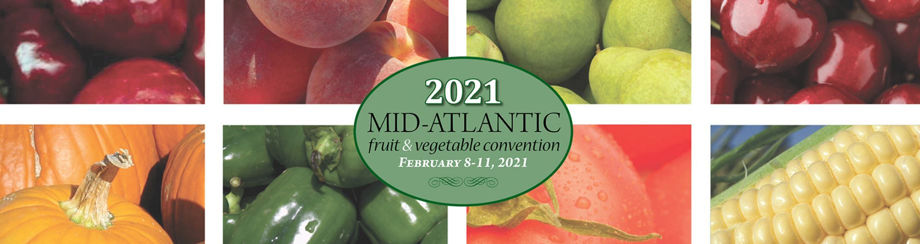

Detailed Educational Program for the
2021 Mid-Atlantic Fruit and Vegetable Convention
updated January 12, 2021

* indicates topic expected to qualify for category pesticide applicator license training credit
** indicates topic expected to qualify for core pesticide applicator license training credit

Monday, February 8, 2021
9:00 to 11:00/11:15 AM
110 Wholesale Marketing
9:00 Produce Industry Update: Where Do Go from Here?- Joseph Watson, Produce Marketing Association
9:45 To Be Announced

120 Third Party Liability
9:00 Preventing Third Party Legal Liability from Operations and Products – Brook Duer, Penn State Ag Law Center
One response to COVID-19 from federal and state governments has been to prioritize the creation of “liability protections,” but exactly for whom and against what type of liability? This session will first explore those questions to help agricultural producers understand what legal liabilities to third parties exist and don’t exist - without the rhetoric. Then the session will proceed to outline an understandable snapshot of exactly and how to best address those liabilities without overthinking things. There will be lots of time for live questions and answers.
130 General Vegetables
9:00 Precision Restoration of the Soil Microbial Rhizosphere Ecosystem – Dr. Richard Woodward
9:45 Anaerobic Soil Disinfestation: A Regenerative Approach for The Management of Soilborne Pests and Pathogens – Erin Rosskopf, USDA-ARS
10:30 Optimizing Anaerobic Soil Disinfestation for Pennsylvania Vegetable Production Systems – Dr. Francesco Di Gioia and Raymond Balaguer, Penn State Univ.

12:00 noon to 2:00/2:15 PM
210 Hydroponics/Greenhouse Vegetables
12:00 Plant Nutrition for Hydroponic Lettuce- Neil Mattson, Cornell Univ.
12:30 Water and Nitrogen Management and Use Efficiency of Hydroponic Leafy Vegetables – Daniel Leskovar, Texas A&M Univ.
1:00 Growing Cucumbers Hydroponically – Thomas Ford, Penn State Extension
1:30 Agronomic Biofortification of Soilless Vegetables for the Production of Functional Greens – Dr. Francesco Di Gioia, Penn State Univ.

220 Honeybees for Pollination
12:00 Honey Bee Biology and Life Cycle – Dr. Margarita Lopez Uribe, Penn State Univ.
12:30 The Beekeeper’s Calendar and Stressors – Dr. Robyn Underwood, Penn State Univ.
1:00 How to Get Started with Honey Bees – Thomas Butzler, Penn State Extension
1:30 Products of the Hive – Dr. Robyn Underwood, Penn State Univ.

230 Post-Harvest Food Safety
12:00 Food Safety Concerns of Packing Equipment - Chris Callahan, Univ. of Vermont
12:45 Newly Proposed FSMA Rules: What You Need to Know– Dr. Emily Griep, United Fresh Produce Association
1:30 FSMA Inspection Update – Kim Carlen, Penna. Dept. of Agric.

2:30 to 4:30/4:45 PM
310 Creative Marketing
2:30 Creative Marketing Discussions & Interviews with Innovative Beginner Farmers - Brendon Pearsall, RU Ready 2 Farm Program, Rutgers Univ.
3:00 Challenges & Opportunities in Urban Farmers Markets – Lauren Errickson, New Brunswick Community Farmers Market
3:30 Expanding My Farmers Market in 2020 – Lenny and Lauren Prezorski, Cold Spring Farms
4:00 What’s Happening at Snapping Turtle Farm? – Alison Akbay, Snapping Turtle Farm

0320 Ag Workplace/Legal Compliance COVID-19
2:30 Ag Workforce Legal Compliance Check-Up – Brook Duer, Penn State Ag Law Center
2020 was been an eventful year for federal and state governmental changes to laws which impact the employer-employee relationship. Many of those changes came and went with the change of calendar year. Some are still with us. This session will attempt to arm agricultural employers with the chance to do a “check-up” on their compliance with current changes/requirements, as well as provide lots of information on where to go for answers and guidance. There will be lots of time for live questions and answers.
0330 Specialty Vegetables
2:30 Mid-Atlantic (NE) Demand for Ethnic Produce - Dr. Ramu Govindasamy, Rutgers Coop. Extension
3:15 Baby Hemp as a New Salad Green – Dr. Neil Mattson, Cornell Univ.
3:45 Asian Vegetable Variety Selection and Production - Dr. Lewis Jett,, West Virginia Univ.

Tuesday, February 9, 2021
9:00 to 11:00/11:15 AM
0410 Sweet Corn
9:00 **The Worker Protection Standard and the AEZ Change - James Harvey, Penn State Univ.
9:30 *IPM in Sweet Corn - Practices and Resources: Plus an App for That - Marion Zuefle, Cornell Univ.
10:15 *Ear-Feeding Insect Control – Dr. David Owens, Univ. of Delaware

0420 Economies of Online Sales
9:00 Financial Considerations of Distribution, and Delivery Services: Make them Complimentary, Not Overwhelming - John P. Wodehouse, Penn State Extension
9:30 Data Needed to Calculate Online Break Even - Maria Graziani, Penn State Extension
10:00 Profitability of Distribution & Delivery Services: Are You Making Money at it? - Lynn Kime, Penn State Extension
10:30 Cost Considerations for Long Term: Know When to Trim the Business Plan - Annie Miller, Penn State Extension
11:00 Questions and Answers with speakers

0430 Tree Fruit Entomology
9:15 *Get Ready for the Big 10 in 2021: Periodical Cicada Brood 10 That Is - Dr. Chris Bergh, Virginia Tech
9:45 *Recent Progress on Preventing Ambrosia Beetle Attacks in Apple Plantings; Plus, the NEWA Rebuild and Updated Insect Prediction Models - Dr. Arthur Agnello, Cornell Univ.
10:15 *Codling Moth and Oriental Fruit Moth Are Back - Are You Ready? - Dr. Greg Krawczyk, Penn State Univ.
10:45 **Rainfast, Persistence & Performance Attributes of Insecticides for Tree Fruit IPM - Dr. John Wise, Michigan State Univ.

12:00 noon to 2:00/2:15 PM
0510 Soil Health/Cover Crops
12:00 Lessons from Long-Term Cover Crop Research in the "Salad Bowl of the World"- Dr. Eric Brennan, USDA-ARS-CIPR
12:30 Improving Soils in High Tunnels with Cover Crops – Dr. Julie Grossman, Univ. of
Minnesota
1:00 “Grow Your Own” Soil Microbiomes – Dr. Mary Ann Bruns, Penn State Univ.

0520 E-Commerce – Platform and Marketing Options
12:00 Platforms, Social Media and Email Marketing Options Presentation - Maria Graziani, Penn State Extension
1:05 Panel Discussions of Farms, Farm Co-ops, CSA’s with E-commerce Platforms - John P. Wodehouse, Annie Miller, Penn State Extension, moderators
2:05 Questions and Answers

0530 Lunch/Learn - Vegetables
12:00 Culinary Breeding Network and the Importance of Vegetable Quality - Lane Selman, Oregon State Univ.
12:30 Discussion with Lane Selman – moderated by Dr. Francesco Di Gioia, Penn State Univ.
1:00 Crop Protection Industry Show and Discussion – moderated by Dr. Timothy Elkner and Dr. Beth Gugino, Penn State Extension

2:30 to 4:30/4:45 PM
0610 Organic Vegetable Production
2:30 Soil-Biodegradable Mulch for Organic Production – Carol Miles, Washington State Univ.
3:00 To Be Announced
3:30 Impact of Cropping Systems and Management Practices on Colored-Flesh Potato Nutrient Quality- Dr. Gladis Zinati, Rodale Institute
4:00 Reducing Tillage in Organic Vegetable Systems – Dr. Erin Silva, Univ. of Wisconsin

0620 General Vegetables
2:30 Compact Bed Geometry: An Effective Strategy to Reduce Costs and Risks and Improve Sustainability for the Vegetable Plasticulture Systems – Dr. Sanjay Shukla, Univ. of Florida
3:15 **Introduction to FieldWatch – Jamie Kopco, Penn State Extension
3:45 Soil-Biodegradable Plastic Mulch as Sustainable Alternative to Polyethylene Mulch – Dr. Carol Miles, Washington State Univ.

0630 Tree Fruit: Plant Health
2:30 *The Biology & Management of Bitter Rot of Apple - Phillip Martin, Penn State Univ.
3:00 *Alternative Controls for Apple Replant Disease – Using Mustard Meal & Carbon Applications to Shift to Beneficial Root Microbiomes - Tianna DuPont, Washington State Univ.
3:45 *Rizophagy: How Plants Farm Microbes - Dr. James White, Rutgers Univ.
4:30 MSHS Executive Committee Meeting
4:40 SHAP Annual Business Meeting

Wednesday, February 10, 2021
9:00 to 11:00/11:15 AM
0710 Vine Crops
9:00 Seedless Watermelon Variety Trial Results – Dr. Gordon Johnson, Univ. of Delaware
9:30 Vertical High Tunnel Specialty Melon Production: Variety Performance, Food Safety and Consumer Response – Petrus Langenhoven, Purdue Univ.
10:00 *Understanding Root Diseases of Vine Crops - Anthony Keinath, Clemson Univ.
10:30 **Pesticides and Pollinators – Jamie Kopco, Penn State Univ.

0720 Cole Crops
9:00 *Managing Common Diseases of Cole Crops - Dr. Beth Gugino, Penn State Univ.
9:30 *Diamondback Moth: One of Several Insect Pests of Concern – Riley Harding, Cornell Univ.
10:00 Evaluating Broccoli Cooling and Handling Operations to Extend Quality – Dr. Steven Sargent, Univ. of Florida
10:30 What’s New in Broccoli, Cauliflower, Cabbage, and Other Brassicas – Atlee Burpee, Sakata Seed America

0730 Small Fruit
9:00 *How Did I Get Anthracnose in My Strawberry Field? - Phillip Martin and Kathy Demchak, Penn State Univ.
9:30 *Strawberry Diseases: Current Issues and Management - Dr. Mengjun Hu, Univ. of Maryland; Kathy Demchak, Penn State Univ.; Dr. Andrew Wyenandt, Rutgers Univ.
10:15 Matted-Row vs. Plasticulture Strawberries: What Works Best on our Farm and Why – John Shenk, Shenk’s Berry Farm; Wade and Ben Butler, Butler’s Orchard; Michael Groszkiewicz, Mason Farms

0740 Tree Fruit:Horticulture/Physiology
9:00 George Goodling Lecture: Honeycrisp Nutrition to Reduce Bitter Pit - Dr. Lailiang Cheng, Cornell Univ.
9:45 **Protecting Water Resources During Mixing and Loading - Ryan Selking, Penn State Univ.
10:15 Effect of Rootstocks on the Quality Characteristics of Honeycrisp Fruit - Dr. Macarena Farcuh, Univ. of Maryland
10:35 Use of Reflective Materials & Other Technologies to Improve Fruit Color in High Value Apple Cultivars - Mario Miranda Sazo, Cornell Univ.

12:00 noon to 2:00/2:15 PM
0810 Tomatoes
12:00 Building a Tomato Nutrition Program from the Soil Up- Steve Bogash Marrone Bio Innovations
12:45 *The Potential for Implementing Nano-Technology-Based Approaches in Plant Disease Management - Dr. Mathews Paret, Univ of Florida
1:30 *BioUnite™ - The Integration of Biological and Chemical Controls to Manage Insects and Diseases on Tomatoes – Dr. Timothy Johnson, Marrone Bio Innovations

0820 Vegetable Biocontrols
12:00 Research & Development Update on Biopesticides - Gregory Clarke, Valent USA; Greg Rodgers, Certis; and Steven Bogash, Marrone Bio Innovations
12:45 * Evaluation of an Isolate of Bacillus subtilis for Biocontrol of Phytophthora Blight of Pepper – Dr. Jeana Hansel, Plant Pathologist
1:15 *Vegetable Transplant IPM – Jessica Crabtree, Wegman’s Organic Farm and Orchard
1:45 *How to Avoid Epic Failures when Utilizing Biopesticides – Steven Bogash, Marrone Bio Innovations

0830 Agritourism
12:00 Legal Considerations for Agritourism - Jacqueline Schweichler, Penn State Univ.
12:30 Agritourism Online Customer Experience Best Practices – Sarah Cornelisse, Penn State Univ.
1:00 Best Practices for Developing Agritourism Trails - Claudia Schmidt, Penn State Univ.
1:30 Lessons Learned from COVID-19 and the Way Ahead for Agritourism – Hugh McPherson, MaizeQuest

0840 Lunch/Learn Tree Fruit
12:00 Color Enhancing Technologies for Apples: Reflective Fabrics and Defoliators - Grower Panel
12:45 Evaluating the Use of Reflective Groundcovers on Fruit Quality of Honeycrisp and Fuji Apple Cultivars in the Mid-Atlantic – Dr. Macarena Farcuh – Univ. of Maryland
1:30 Grower Discussion

2:30 to 4:30/4:45 PM
0910 General Vegetables
2:30 Splice Grafting Watermelon Increases Efficiency and Yield Under Verticillium Wilt Pressure – Carol Miles, Washington State Univ.
3:00 Snap Bean Production- Julie Kikkert, Cornell Coop. Extension
3:30 Onion Variety Trial Results – Thomas Butzler and Timothy Elkner, Penn State Extension
4:00 **Pesticide Formulations Demonstration – Genevieve Christ, Penn State Extension

0920 Farm Markets Post-COVID
2:30 Retail During & Post COVID- Brian Moyer, Penn State Extension
3:00 Changes We Made to Our Businesses During COVID – Panel - Stacey Mullen, The Berry Farm & Orchard; Ed Weaver, Weaver’s Orchard; Caleb Torice, Tabora Farm

0930 Small Fruit
2:30 What’s New in Blackberry Varieties from the Univ. of Arkansas - Dr. John Clark, Univ. of Arkansas
3:00 *Weed Control in Brambles – Dr. Eric Hanson, Michigan State Univ. (emeritus)
3:45 What We Learned about Pick-Your-Own in 2020 – Kurt Alstede, Alstede Farms; Craig Pallman, Pallman Farms; Guy Moore, Larriland Farm

0940 Stone Fruit
2:30 **Pollinator Protection - Jamie Kopco, Penn State Univ.
3:00 Ernie Christ Memorial Lecture: Developing New Peach Cultivars for the Eastern U.S. - Dr. Ksenija Gasik, Clemson Univ.
3:45 Opportunities & Growth for the Peach Industry: A Look at Market Impacts to Selling Peaches - Kay Rentzel, National Peach Council
4:15 *Fall Application of Ethephon for Bloom Delay in Peach & Sweet Cherry: Pros & Cons - Dr. Sherif Sherif, Virginia Tech Univ.
4:30 MSHS Annual Meeting

0950 Spanish – see end of program for more detail on the Spanish session
2:30 Keys to Success in Planting, Establishing, and Tree Training in Orchards during the First Year - Mario Miranda Sazo, Cornell Coop. Extension
3:30 Sergio and Silvia—The Rosario Team - Sergio Rosario and Silvia Rosario, co-founders and co-owners of Rosario Brothers LLC, an agricultural company for contract tree pruning/grafting/budding

7:00 to 8:00 PM
Bring Your Own Ice Cream Social
We realize virtual food events just aren’t quite the same but if you would like to visit with other growers and share stories of your year like you do at the Ice Cream Social in Hershey, we will be providing four separate Zoom rooms where you can chat with other Convention attendees while enjoying your own ice cream (be sure to get some Hershey’s chocolate syrup or Reese’s Pieces to make the experience more authentic) and some chips. We will have separate Zoom rooms for Tree Fruit Production, Vegetable Production, Small Fruit Production and Marketing discussion groups – all very informal so come prepared to share, ask questions and listen.

Thursday, February 11, 2021
9:00 to 11:00/11:15 AM
1010 High Tunnels
9:00 Nitrogen Input Effects on Yield and Quality of Grafted and Non-Grafted Tomato Grown in High Tunnels - Dr. Francesco Di Gioia and Andrew Blunk, Penn State Univ.
9:45: **Best Practices to Limit Phytotoxicity from Pesticides on High Tunnel Crops– Thomas Ford, Penn State Univ.
10:15 Opportunities for Growing Grafted Cucumbers in High Tunnels – Dr. Wenjing Guan, Purdue Univ.

1020 Potatoes
9:00 Nurse Crops in Potatoes- John Jemison, Univ. of Maine
9:30 *Blackleg, Stem Rots, Dickeya, Pectobacterium, Bacterial Soft Rot – Dr. Steve Johnson, Univ. of Maine
10:00 Growing Russets in PA - Can it be Done? – Robert Leiby, PA Coop. Potato Growers
10:20 PA Potato Variety Trials – Xinshun Qu, Penn State Univ.
10:40 Potato Issues in 2020 and What Can We Expect in 2021 – Robert Leiby, PA Coop. Potato Growers

1030 Small Fruit – Blueberries
9:00 **Pollinator Protection - Leah Fronk, Penn State Extension
9:30 There Is NO Perfect Blueberry Variety, But There ARE Many, Many Choices: Some Advice – Dr. Mark Ehlenfeldt, USDA-ARS
10:00 *The Blueberry Cane Pathogen Complex and Approaches to Understanding Soil Health – Dr. James Polashock, USDA-ARS
10:30 How Blueberry Cultivars with Southern Highbush Backgrounds Access Nutrients Differently than Standard Varieties in Upland Soils - Dr. Chris Walsh, Univ. of Maryland

1040 Tree Fruit: Ag Engineering
9:00 **Utilizing Intelligent Sprayers Benefit Growers and the Environment - Dr. Heping Zhu, USDA-ARS & Steve Booher, Smart Guided Systems.
9:30 Computer Vision & Drone Imaging in Apple Orchards - Dr. Dana Choi, Penn State Univ.
9:50 Precision Irrigation Systems for Tree Fruit Production - Dr. Long He, Penn State Univ.

Lightning Talks
10:10 Concept Design of an Integrated Robotic Pruner for Apple Tree Pruning - Azlan Zahid, Penn State Univ.
10:20 Measuring Accurate Tree Canopy Density for Developing a Precision Spraying System – Md. Sultan Mahmud, Penn State Univ.
10:30 UAV-Based Heating Requirement Determination for Frost Management in Apple Orchards - Wenan Yuan, Penn State Univ.
10:40 Fall Foliar Nutrition Programs: What is Really Needed? - Dr. Lailiang Cheng, Cornell Univ.

1050 CSAs
9:00 Harvie Farms Local – A Model for Multi-farm Home Distribution to Consumers – Simon Huntley, Harvie and Small Farm Central
9:45 A Better Way to Satisfy CSA Members - Arthur King, Harvest Valley Farms
10:30 Our CSA at Strite’s Orchard Jonathan Strite, Strite’s Orchard

12:00 noon to 2:00/2:15 PM
1110 Pumpkins/Winter Squash
12:00 *Management Considerations for Downy Mildew and Plectosporium Blight on Pumpkin – Dr. Beth Gugino, Penn State Univ.
12:30 It All Started with Pumpkins & Strawberries – Bruce Hellerick, Hellerick’s Family Farm
1:00 *Review of Weed Control in Pumpkins – Dwight Lingenfelter, Penn State Univ.
1:30 *Integrated Pest and Pollinator Management (IPPM) in Pumpkins – Dr. Shelby Fleischer, Penn State Univ.

1120 Potatoes
12:00 *Designing a Fungicide Program for Potatoes- Dr. Steve Johnson, Univ. of Maine
12:30 PotatoesUSA – Blair Richardson, PotatoesUSA
12:50 National Potato Council - Mike Wenkel & Kam Quarles, National Potato Council
1:10 PA Cooperative Potato Growers, Nathan Tallman, PA Coop. Potato Growers
1:30 **Minimizing Drift to Prevent Herbicide Injury to Potatoes – Dwane Miller, Penn State Univ.

1130 Lunch/Learn - Small Fruit
12:00 Strawberry Grower Discussion: 2020 Issues and Experiences - moderated by Kathy Demchak and Robert Pollock, Penn State Extension
1:00 Blueberry Grower Discussion: New and Recurring Challenges – moderated by John Esslinger and Kathy Demchak, Penn State Extension

1140 Digital/Social Marketing
12:00 Social Selling - Sarah Cornelisse, Penn State Univ.
12:30 Email: the King of Social Media - Ginger S. Myers Univ. of Maryland Extension,
1:00 Become a Social Agriculture Advocate! - Michele Walfred, Univ. of Delaware
1:30 Making Videos for Social Outlets, Peter Coffey Univ. of Maryland Extension

2:30 to 4:30/4:45 PM
1210 General Vegetables
2:30 Developing Sensor-Based Smart Irrigation Systems for Vegetable Crops - Long He, Haozhe Zhang, Penn State Univ.
3:00 Decision Support Systems for the Rational Site-Specific Management of the Fertigation of Tomato – Antonio Elia, Univ. of Foggia
3:45 Application of Sensor-Based Automated Irrigation and Decision Support System for the Fertigation Management of Fresh-Market Tomato in Pennsylvania – Francesco Di Gioia, Haozhe Zhang, Long He, Antonio Elia Penn State Univ./Univ. of Foggia
4:15 Panel Discussion

1220 Potatoes
2:30 *Managing Diseases in Potato Storages – Todd Forbush, Techmark, Inc.
3:15 Improving Soil Health While Growing Potatoes – Dr. John Jemison, Univ. of Maine
4:00 *Potato Insect Control Update – Dr. Thomas Kuhar, Virginia Tech

1230 Small Fruit – Blueberries
2:30 How to Reduce Soil pH and Maintain It in a Good Range for Blueberries – Dr. David Bryla, USDA-ARS
3:00 Practical Approaches to Correcting Irrigation Water pH and Bicarbonate Issues for Blueberries (tentative) - Thomas Ford and Kathleen Demchak, Penn State Extension; Dr. David Bryla, USDA-ARS (tentative)
3:30 Organic Materials for Soil Amendment and Mulching - The Good, The Bad, and The Ugly – Dr. Bernadine Strik, Oregon State Univ.
4:00 Good Fertilizer Nutrient Management in Blueberry – Tips for Proper Tissue Sampling and Fertilizer Do’s and Don’ts – Dr. Bernadine Strik, Oregon State Univ.

1240 Stone Fruit
2:30 ** Changes in Application Exclusion Zone for Orchard Pesticide Applications - James Harvey, Penn State Univ.
3:00 *Integrated Weed Management in Peach Orchards - Dr. Thierry Besancon, Rutgers Univ.
3:30 Sweet Cherry Pruning & Training in Evolving Production Systems & the Physiological Basis - Dr. Greg Lang, Michigan State Univ.
4:15 *Bacterial Diseases of Stone Fruit - Dr. Kari Peter, Penn State Univ.

Spanish Session Details
The Virtual Mid-Atlantic Fruit and Vegetable Convention Spanish language session to be held on February 10th will be led by Mario Miranda Sazo, Cornell Cooperative Extension, and Sergio Rosario and Silvia Rosario, co-founders and co-owners of Rosario Brothers LLC. Mario will discuss “Keys to Success in Planting, Establishing, and Tree Training in Orchards during the First Year.” In an interactive presentation titled “Sergio and Silvia—The Rosario Team,” the Rosarios will share their professional journey to become highly successful Latino/Hispanic ag-entrepreneurs in Western New York.
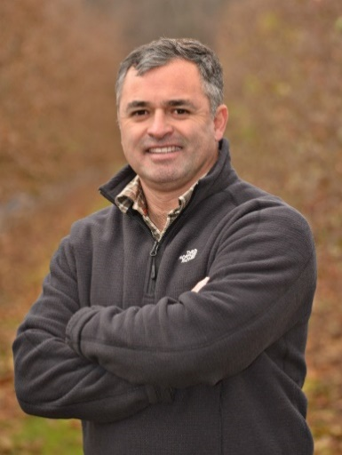
Mario is a Fruit Extension Specialist with the Cornell Cooperative Extension Lake Ontario Fruit Program. In this position, he manages a series of research and educational projects aimed at solving practical fruit production problems that will increase the profitability of the state’s fruit industry. His program is largely field oriented and of an applied nature with significant Extension outreach. He works in nine areas to accomplish his goals: (1) orchard systems, (2) rootstocks, (3) tree nursery production, (4) maximum new tree growth, (5) crop load and canopy management, (6) irrigation/fertigation/soil nutrient management, (7) orchard mechanization for higher labor efficiency, (8) Spanish-speaking training, and (9) strategic thinking and innovation for future adoption of digital agriculture technologies. Before Mario joined the Cornell Fruit Extension team, he worked as a product development manager for BASF in Latin America, Harris Moran Seed Company in California, and managed the IR-4 field residue program at the Department of Horticulture, Cornell University. His academic training is in agronomy and business (B.S.) and in horticulture and agronomy (M.S.), University of California, Davis. He is currently pursuing a Ph.D. degree in nutrition physiology and management at Cornell University.
Mario Miranda Sazo, Fruit Extension Specialist, Cornell Cooperative Extension Lake Ontario Fruit Program.
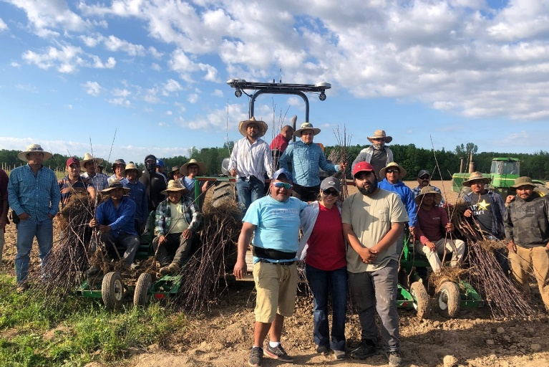
Sergio Rosario and Silvia Rosario, Rosario Brothers LLC., (an agricultural company for contract tree pruning/grafting/budding) will share their story about becoming one of most successful Latino/Hispanic ag-entrepreneur duos in the state of New York. In addition, as graduates of the Cornell Small Farms program for bi-lingual professional development (titled, the Master Class program), the couple will share managerial and workforce development tips for creating efficient and effective teams.
Sergio and Silvia’s extensive experience and entrepreneurial spirits are infectious and inspiring. Originally, from the State of Oaxaca, (Southern Mexico), their journey as a married couple began more than twenty years ago. Sergio (45 years old) and Silvia (39 years old), graduates of the 2019 Cornell Master Class, have built a successful professional career in the Lake Ontario fruit region of Western New York. More importantly, they have raised a beautiful family in the region. Their eldest son, Sergio Jr., 23 years old, who is poised to assume future management of the business, will also join the webinar discussion in February.
In addition to providing custom services for winter/summer pruning, spring grafting, and summer budding in the Lake Ontario fruit region, the Rosarios (Sergio, Silvia, and Sergio Jr., pictured in the middle with their planting team) today proudly own 50 acres of Gala, Honeycrisp, Fuji, NY1, and Evercrisp orchards, all planted at 2 x 11 ft.
Before coming to New York, the couple worked in tomato fields in Florida for three years. In 2000, they moved to Western New York to work for Lamont Fruit Farms, an innovative fruit company where they handled long hours of hard work while learning cutting-edge practices for high-density apple production. Their efforts began to pay off when they started a custom grafting and tree pruning business in 2015. Within a few years, their business reputation grew, with grafting jobs in the spring and summer budding at several on-farm nurseries.
The business has seen continued success. Within the last two years, Rosario Brothers have custom-pruned approximately 600 to 1000 acres of processing and high-density blocks. Last year alone, they grafted more than 700,000 apple trees to new and exciting apple cultivars. Additionally, the Rosarios produce trees for their own nursery, providing jobs to approximately 15 Latino/Hispanic employees. These experiences made the Rosarios integral to the success of the Cornell Master Class program, in which Latino/a farm business owners, managers, and employees share their collective knowledge, while building strong Spanish-speaking networks within the region.
Together, Silvia and Sergio will share their professional journey, as well as their positive perspective on life. This session is sure to be an invaluable experience for all.
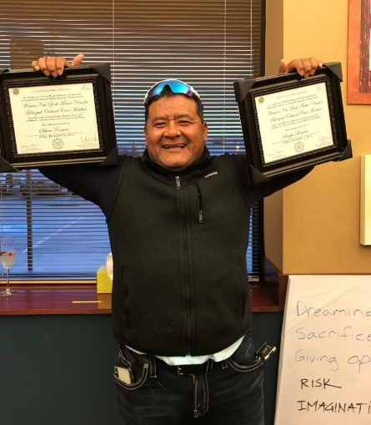
Sergio Rosario holds both his and Silvia’s Master Class certificates during a graduation ceremony at Wegmans Conference Center in Rochester, December 13, 2019.

Sergio (white hat with glasses and gray sweatshirt) and Silvia (blue hat and red jacket) demonstrate various grafting techniques during an indoor workshop organized in the winter months by the Cornell Cooperative Extension Lake Ontario Fruit Program.

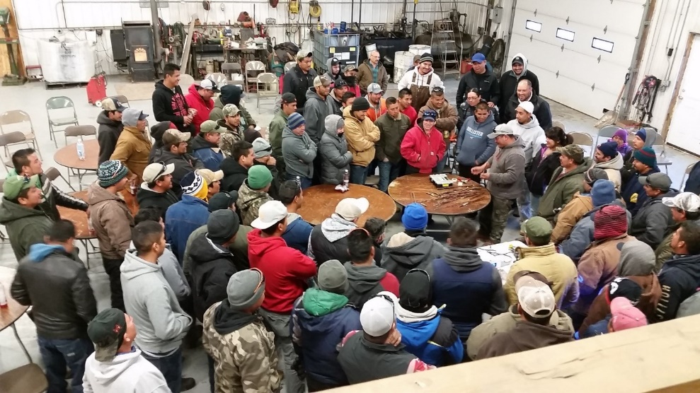
This program is supported by a Penn State Extension Science to Practice Grant.

